**DIGITAL SIGNAL PROCESSING LAB**

**Lab sheet. No: 02**

**NAME: NIKHIL KILARI Roll.No: EE16B017**

**QUESTION 1**

**Aim:**

To find convolution of two finite sequences:

X1 = [4 2 6 3 8 1 5]

X2 = [3 8 6 9 6 7]

**Short Theory:**

Here we need to find and plot the discrete time convolution of X1 and X2 using conv() in MATLAB.

**Key Commands:**

* conv()
* subplot()
* stem
* xlabel()
* ylabel()
* suptitle()

**Result:**

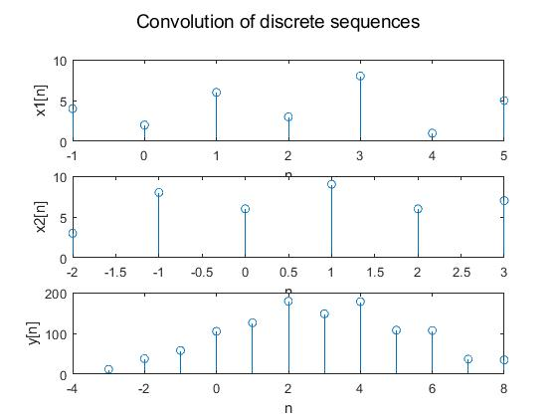

**Inferences/comments:**

* Therefore convolution of two discrete sequences can be easily found using conv() in MATLAB.
* Even though conv gives the desired output the range of time for convoluted signal must be provided by the user.

**QUESTION 2**

**Aim:**

To find auto correlations and cross correlation of the sequences

X1 = [4 2 6 3 8 1 5]

X2 = [3 8 6 9 6 7]

**Short Theory:**

Here we need to find the auto correlations and cross correlation of the signals X1 and X2 as mentioned in the question.

**Key Commands:**

* flip()
* conv()
* stem()
* title()
* xlabel()
* ylabel()
* suptitle()

**Result:**

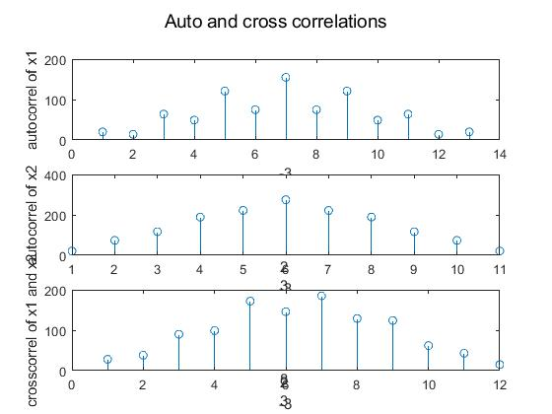

**Inferences/comments:**

**QUESTION 3**

**Aim:**

To generate exponentially growing and decaying complex signal.

**Short Theory:**

1. To generate exponentially decaying signal we define real of z as a positive number
2. To generate exponentially decaying signal we define real of z as a negative number

**Key Commands:**

* exp()
* stem()
* real()
* imag()
* subplot()
* xlabel()
* ylabel()
* suptitle()

**Result:**

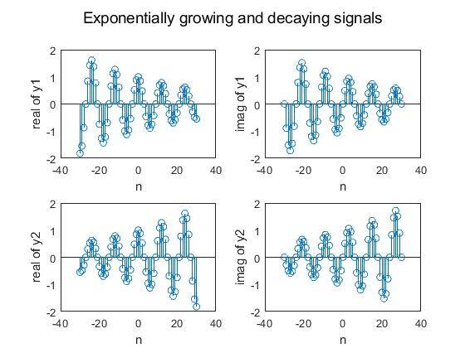

**Inferences/comments:**

* Real part of z as a positive number generates exponentially growing sequence
* Real part of z as a negative number generates exponentially decaying sequence

**QUESTION 4**

**Aim:**

To find the impulse response of the differential equation

y[n] = ay[n-1]+x[n]

**Short Theory:**

y = filter(b,a,X)



Here b is the row vector of the numerator coefficients while a is that of denominator.

**Key Commands:**

* filter()
* stem()
* title()
* xlabel()
* ylabel()

**Result:**

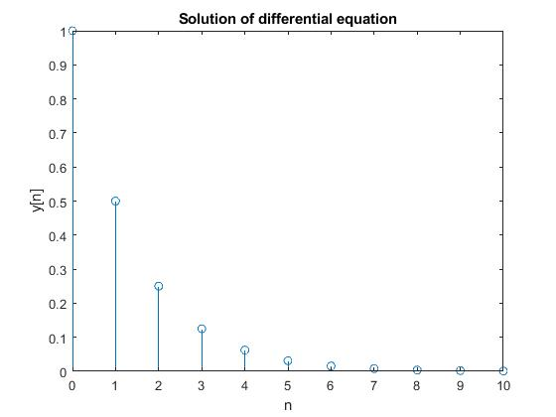

**Inferences/comments:**

* We need to first find the impulse response in frequency domain to know the numerator and denominator coefficients
* We can directly apply the filter to the data through x vector.

**QUESTION 5**

**Aim:**

**Short Theory:**

**Key Commands:**

* exp()
* impz()
* stem()
* imag()
* real()
* subplot()
* title()
* xlabel()
* ylabel()
* suptitle()

**Result:**

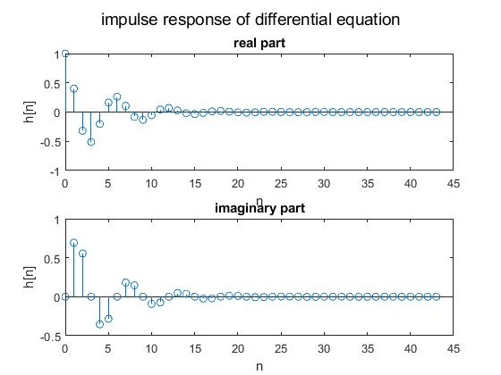

**Inferences/comments:**

**QUESTION 6**

**Aim:**

To generate the impulse response of the difference equation

y[n] = 1.8 cos(π/16) y[n-1] + 0.81 y[n-2] = x[n] + 0.5 x[n-1]

**Short Theory:**

We need to use filter command to find the impulse response of the difference equation. But before doing that we need to find H(z) as we did in the above question.

**Key Commands:**

* cos()
* filter()
* stem()
* xlabel()
* ylabel()
* title()

**Result:**



**Inferences/comments:**

* The impulse response of the difference equation is a decaying signal, it is also causal and stable.